

**MBTA Orange Line Car Interior Redesign**



**Project Proposal**

**EMGT 5220: Engineering Project Management**

**Summer II 2017**

**NEUdesigners**

**Team Members**

Aleksandra Pirog (POC: pirog.a@husky.neu.edu)

Daniel Gallagher

Paul Kfoury

Gaurav Korgaonkar

Peter Veneto

Sarah Witzig

**Team Member’s Contributions**

Aleksandra Pirog

* Draft 1 – Aleksandra researched and organized the Introduction section.
* Draft 2 – Aleksandra created the responsibility chart and documented stakeholders.
* Final – Aleksandra developed the Risk Management plan and edited the document.

Daniel Gallagher

* Draft 1 – Daniel edited Draft 1 and completed the Cover Page.
* Draft 2 – Daniel researched and developed the technical overview.
* Final – Daniel developed the Execution Plan.

Paul Kfoury

* Draft 1 – Paul edited and compiled the sections within Draft 1.
* Draft 2 – Paul developed the WBS and created Microsoft Project resources.
* Final – Paul compiled and edited the document and created the Project Proposal Brief.

Gaurav Korgaonkar

* Draft 1 – Gaurav edited Draft 1 and prompted team feedback.
* Draft 2 – Gaurav developed the team’s budget and financial plan.
* Final – Gaurav wrote the Letter of Transmittal and Executive Summary.

Peter Veneto

* Draft 1 – Peter created the Team Member Contributions and performed research.
* Draft 2 – Peter researched and developed the technical overview.
* Peter – Peter edited the document and created the Project Proposal Brief.

Sarah Witzig

* Draft 1 – Sarah was the author of the sections Purpose and Goals.
* Draft 2 – Sarah contributed to the WBS development and compiled and edited Draft 2.
* Final – Sarah developed the Risk Management plan and edited the revised Draft 2.

Table of Contents

List of Figures vi

List of Tables vi

Letter of Transmittal vii

Executive Summary viii

1 Introduction 1

1.1 Problem 1

1.2 Solution 1

2 Purpose & Goals 2

2.1 Purpose 2

2.2 Goals 2

3 Technical Overview 3

3.1 Seating 3

3.2 Handhold Layout 5

3.3 Material Selection 6

4 Implementation Plan 7

4.1 Work Breakdown Structure (WBS) 7

4.2 Schedule 7

4.3 Responsibility Chart 7

4.4 Resource Allocation 7

4.5 Stakeholders 8

5 Execution Plan 9

5.1 Project Monitoring 9

5.1.1 Cost 9

5.1.2 Length (Time) 9

5.1.3 Resources (Personnel) 9

5.1.4 Quality 9

5.2 Project Control 10

5.3 Project Auditing 10

5.4 Project Termination 11

6 Risk Assessment Management Plan 12

6.1 Risk Identification 12

6.2 Qualitative Risk Analysis 12

6.3 Quantitative Risk Analysis 13

6.4 Risk Response Planning 14

7 Financial Plan with Budget 17

7.1 High Level Details 17

7.2 Budget Justification 18

8 Team Credentials 19

APPENDIX A – WORK BREAKDOWN STRUCTURE 21

APPENDIX B – SCHEDULE AND GANTT CHART 22

APPENDIX C – RACI MATRIX 26

APPENDIX D – BUDGET 27

# List of Figures

Figure 1: Preliminary Folding Seat Schematic 3

Figure 2: Overhead view of preliminary seat layout 3

Figure 3: Seat design in Frankfurt, Germany, which could provide a model for permanent handicapped seats as well as folding seats 4

Figure 4: Potential handhold design, currently in use in the NYC train cars, 5

# List of Tables

Table 1: Project Phase Gates 9

Table 2: Qualitative Risk Matrix 11

Table 3: FMEA Risk Analysis 12

Table 4: Risk Response Planning 13

Table 5: High-Level Project Budget 14

# Letter of Transmittal

August 24, 2017

Mr. Loay Abdelkarim

Design Manager

Massachusetts Bay Transportation Authority

10 Park Plaza, Boston

MA 02116

Dear Mr. Abdelkarim,

As we all know that during peak commuting hours, the seating capacity of the Massachusetts Bay Transportation Authority (MBTA) Orange Line trains is not enough for all the commuters. Thus, the commuters lose out on precious time and comfort. We feel that the city’s public transportation needs improvement as the population of Boston keeps on growing.

We hereby submit a proposal to redesign the seating of the MBTA Orange Line train cars to accommodate more commuters without compromising their comfort. This proposal contains information associated with the technical overview, implementation plan, execution plan, risk management plan, and financial plan for this project.

The team proposes a budget of $75,664 for successful on-time completion of this project. This reflects the wages of on-staff engineers and external engineers, cost of rapid manufacturing, testing the prototypes of the new designs and conducting the consumer surveys.

This team believes that this project will not only benefit MBTA economically, but will also make the ride more comfortable and enjoyable for the commuters. Please feel free to contact us with any questions or concerns. We look forward to working with you in the future.

Best Regards,

Aleksandra Pirog

Paul Kfoury

Sarah Witzig

Peter Veneto

Daniel Gallagher

Gaurav Korgaonkar

# Executive Summary

The MBTA orange line is known as the unofficial commuter rail as it goes far outside of Boston and is used by thousands of commuters daily. There is an increase in number of commuters every year and it is difficult for the orange line to handle it. The current seat configuration of the MBTA orange line fails to accommodate the commuters during peak hours. Thus, they lose out on time and resort to other measures, which are not economical. The team is proposing a project that will help the MBTA to provide solutions to this problem for the satisfaction of their customers. The varied engineering expertise of the team is beneficial for the project in numerous ways.

This project is focused on redesigning the seating of the orange line train cars to help the MBTA to improve the seating capacity of the train cars. The redesign will include reselection of materials for the seats, altering the style of seats used, reconfiguration of the seating arrangements and handholds. The technical overview contains the detailed description of the redesign and the execution plan provides the deadlines and the way to approach the project. The RACI matrix will define the responsibility and accountability of the resources involved in this project.

The total proposed budget for a project of this scale is expected to be $75,664. This budget includes the wages of on-staff engineers and external engineers, cost of rapid manufacturing, testing the prototypes of the new designs and the consumer surveys. Risk management plans will be developed to identify and analyze the risks associated with the project.

The implementation plan has four phases: Initiation, Planning, Execution, and Termination. Initiation and Planning are expected to take a month with the focus to outline the purpose, goals, objectives and planning the future course of the project. Execution phase is where most of the work is supposed to happen, where the team will develop and test the prototypes. Hence, this phase will utilize most of the budget as well as take up most of the schedule. At the end, Termination will include compilation and submission of all the deliverables.

# Introduction

## Problem

During peak commuting hours, the Massachusetts Bay Transportation Authority (MBTA) Orange Line trains are packed to the doors, with commuters looking to fill any empty space they can find. The current seat configuration fails to optimize both commuter capacity and comfort. The city’s need to provide public transportation increases as the population of Boston grows. From 2008 to 2014, there was an 11 percent increase in commuter trips, a rise greater than any of the other top 10 US cities, with heavy rail subway transit increasing by 5.8 percent in 2014 alone[1]. Finding a seat, however, is not the only problem. A columnist from the Boston Magazine describes the seats as if they were, “the Russian roulette scene from *Deer Hunter,* but with wet stuff of unidentified origin”[2]. These feelings are unanimously shared by riders, as the seats were last installed in 1992, with the fabric having only been replaced three times since, the most recent of which in 2006[3]. As emotions mount, commuters are steadily opting out of the MBTA Orange Line and are using other forms of transportation such as Uber, car sharing or even reverting back to driving themselves. As Boston’s population is expected to continue, it is necessary for the MBTA to provide viable solutions to meet the needs of their customers.

## Solution

The solution to this problem is to redesign the seating of the Orange Line train cars based on the MBTA’s desire to improve upon car capacity during peak commuting hours. In order to also give commuters a comfortable ride, it is proposed that cars will be remodeled with the objectives of creating a safe and spacious environment. This design will include ergonomic, foldable seats manufactured with a finish intended to enhance user safety by repelling germs and liquids. With proper materials chosen, upkeep and repair will be simplified, and cleaning downtime will be reduced. The increase in space will maintain priority and handicap seating requirements. Handhold location and design will be carefully chosen in order to create an enjoyable and safer experience for the traveling public. Our interdisciplinary team will address the problems stated above by gathering data from other hub rail cities and analyzing rider statistics from MBTA heavy rail passengers. We have diverse experience in customer interaction as well as varied engineering expertise. Our goal-oriented team has delivered high quality products, and are confident in their interpersonal skills to develop an interior design that will appeal to the Boston commuter population. Currently the MBTA operates at a loss of 61 cents per rider on their heavy rail trains (mostly due to mechanical and infrastructure issues)[4]. Our proposed design aims to offset this loss by increasing customer satisfaction, thereby increasing ridership.

# Purpose & Goals

## Purpose

Our proposed project purpose is to help the MBTA improve car capacity during peak commuting hours. The goal of this project is to develop and implement an interior redesign for the MBTA’s Orange Line, in order to increase and optimize capacity and commuter comfort. Our group stands by returning enjoyable commuting to the populace and make Boston’s underground shine brighter than ever.

## Goals

The scope for this project is to identify possible areas of improvement in the current interior design of MBTA's Orange Line cars, and implement these changes. The project goals must be considered in terms of two important stakeholders: the MBTA and the Orange Line commuters.

Goals for the Client, the MBTA

* Design new seating and handhold configuration to increase capacity of Orange Line train cars
* Create a train car interior which can be cleaned with less effort than the current design

Goals for the Orange Line Commuters

* Design a seating and handhold configuration which improves the current rider experience
* Offer a more hygienic experience in the Orange Line cars
* Maintain current allowances for handicapped seating

Goals for Project Implementation

* Effective communication between team functions, the MBTA, and external suppliers
* Complete the redesign quickly and thoroughly, and implement the new design without unnecessary strain on the MBTA.
* Produce a complete and robust risk matrix and contingency implementation plan

# Technical Overview

This technical overview describes how the train interior will allow for more passengers to ride during peak commuting hours, while simultaneously providing a more enjoyable riding experience during all hours. This overview is broken down into the three main design challenges the technical team will face: seating, handholds, and material selection. Aesthetic considerations will come into play later in the project, when consumer surveys are taken.

## Seating

The seat layout must be carefully planned in order to make improvements on the existing layout without compromising the passengers’ riding experience. The seats will be changed from the current solid seat to a folding seat design. This design will include a spring loaded or similar system that returns the seat to the upright position when not in use. Signs within the cabin would instruct commuters to leave the seats folded up during commuting rush hours, when there is only standing room in the cabin. Designs similar to ours are commonly used in other mass transit and public places (such as those found in Fenway Park), so most commuters are expected to know how to lower the seat. The introduction of folding seats will reduce the overall seat footprint and allow for more standing commuters than a stationary seat, as seen in Figure 1. Near each doorway on the train car, there would be two permanent handicapped seats which do not fold up, seen below in Figure 2.

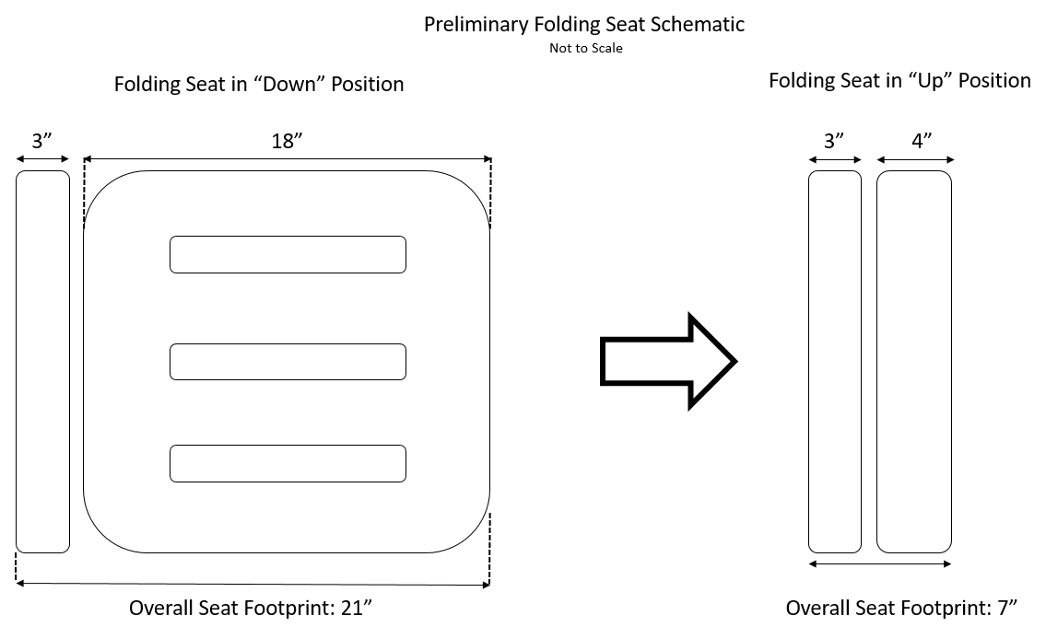

**Figure 1: Preliminary Folding Seat Schematic**

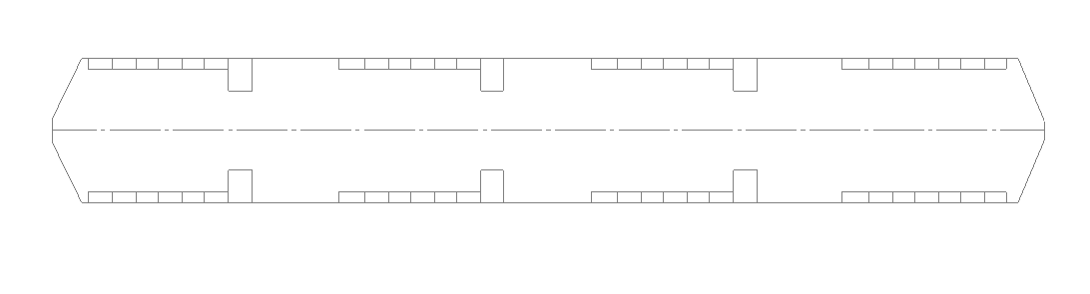

**Figure 2: Overhead view of preliminary seat layout**

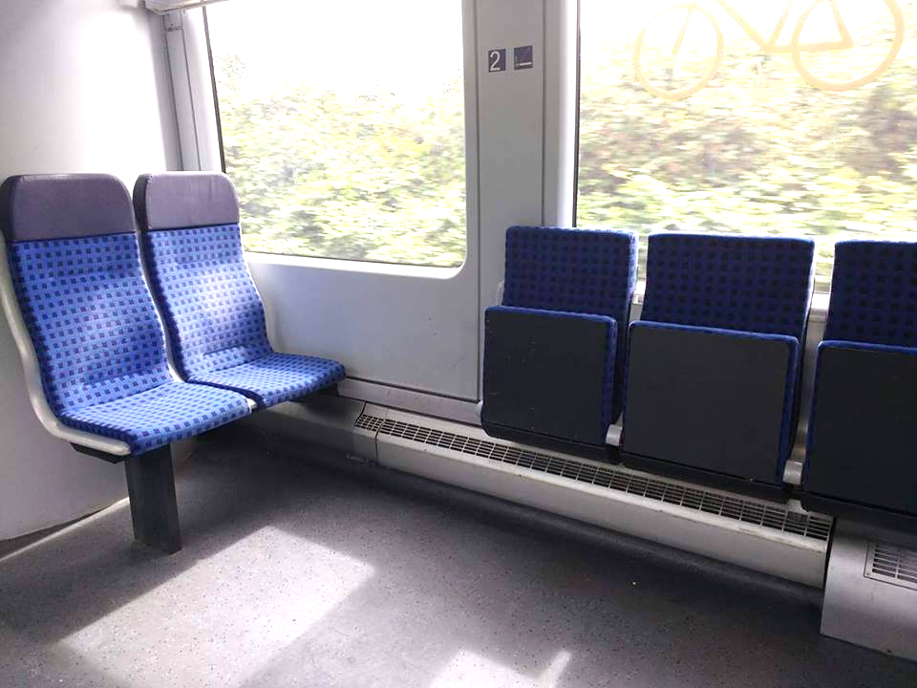

**Figure 3: Seat design in Frankfurt, Germany, which could provide a model for permanent handicapped seats as well as folding seats[5]**

The seat bottom will be hinged onto the back of the seat, which will be embedded in the side of the train car for stability. The seat will go through extensive abuse and fatigue failure testing to ensure it will remain intact and operational throughout its lifetime. The seats will also be able to withstand a force of 250 lbs. spread evenly across the front of the seat edge, applied vertically towards the floor. The seat will also be able to withstand 250 lbs. spread evenly across the top of the seat back, applied horizontally from the front of the seat towards the back. Both loading cases should be applied without permanent deflection or deformation of the seat. Finally, the seat will be able to withstand a load of 35 lbs. dropped from a height of 12 inches over 20,000 cycles, with no permanent deformation or deflection.[6]

The seat will also be ergonomically designed for comfort. Seat designs from other well-known applications such as stadium seating or other mass transit systems will be studied and used to create a seat shape that suits the rider. At the same time, the seat should also be easy to clean so that dirt and other substances do not build up on the seats. In order to do this, seat shape and material selection will be balanced to ensure the seats are both comfortable and easy to clean.

## Handhold Layout

Currently, the handholds on the Orange Line cars are made up of horizontal straight aluminum extrusions, reaching across rows of seats, roughly 7 feet high. These handholds occasionally have hanging leather straps for commuters who cannot reach the bar to grab on to, allowing them to have a safe ride. Currently, these bars do not do an adequate job of providing enough handholds for riders. As this project is seeking to increase the total number of riders per car, the handhold layout must be redesigned.

Three new handhold designs are being proposed that can be used in tandem to increase the number of riders who can hold on to handholds while riding:

1. The first involves placing a T-shaped bar affixed to the underside of the seat. When these seats are folded into the “Up” position, the bar will be exposed, giving standing riders a handrail at about waist level for the average adult.
2. As the current elevated horizontal handrails are rather high and cannot be reached by certain riders, and the leather straps often break off of the horizontal handrails, a new design is proposed: in this design, 12-18” sections of the bar will alternate between 6 and 7 feet from the train floor, and will be placed above the seats. By incorporating this design, shorter riders have the ability to hold onto the handrails, and taller riders can travel beneath the bar without the worry of bumping their heads.
3. For those passengers not able to reach the first two handrail designs (located towards the sides of the train cabin), vertical bars will be placed in the exact center of cabin. These will be affixed to both ground and ceiling, and could range from a simple rod to a series of connected rods to increase the number of people who could hold on. These would be placed to have the proper 32” clearance required for wheelchairs. See Figure 2 for reference.

|  |  |
| --- | --- |
|  |  |
| **Figure 4: Potential handhold design, currently in use in the NYC train cars[7],[8]** | |

## Material Selection

The material selected for the seats must be strong enough to withstand overweight passengers or heavy objects that may be placed on the seats without deformation or component failure. The material must also be nonporous and nonabsorbent. By using a material that is nonporous and nonabsorbent, the team can incorporate seats that resist staining and absorption of spilled liquids, and also allow for easy cleaning of the seats themselves, assisting in creating a cleaner commuting experience. To increase rider enjoyment, the material must not be uncomfortable. As it is difficult to test rider comfort, standard materials used in outdoor furniture manufacturing will be considered, as they are known for their comfort. Due to the use of the product as chairs, the tolerancing on the seat components does not need to be very tight, allowing reduced costs through less costly manufacturing techniques. Finally, the seat material must be relatively low cost. This project is intensive, retrofitting the roughly 120 cars currently in use. In order to reduce the cost of the project, expensive or specialty materials will not be considered.

The material selected for the hand rails should be able to withstand years of use, while still being easy to clean and relatively low cost. Following the current material selection for handrails, a lightweight metal alloy, such as an aluminum, will be incorporated. These metals can be bought as stock extrusions that can then be cut, bent, and formed to the desired shape without great difficulty. The material must also have corrosion resistance to improve the component lifespan, and be nonporous and easy to clean. Much like the seats, the tolerancing on these parts does not need to be high, saving costs on manufacturing.

# Implementation Plan

## This section details the layout of the work breakdown structure, and the subsequent creation of our schedule, responsibility chart, resource allocation, and stakeholders. The implementation plan focuses on following the standard project lifecycle, and minimizes external resources to lower costs. Internal communication is facilitated by the WBS, schedule, and responsibility chart, and external communication is considered via resource allocation and the list of stakeholders.

## Work Breakdown Structure (WBS)

The Work Breakdown Structure follows the general project lifecycle, and is carried out in four phases: Project Initiation, Planning, Execution, and Termination. Monitoring and Control are covered in sections 5.1 and 5.2 of this report, respectively. The full WBS can be found in Appendix A.

In Initiation, milestones include the appointing of a project team, and the completion of the project charter. In Planning, the WBS, Schedule, and Budget are developed, and the literature research can begin. In Execution, the bulk of project budget and tasks are carried out, including design creation and finalization, writing of SOPs, and prototyping and testing with external manufacturers. Finally, in Termination, all deliverables will be grouped and delivered to the MBTA.

## Schedule

The schedule follows the Work Breakdown Structure, and considers various factors, such as the availability of staff, timelines of external contractors, and the ability for some teams to work simultaneously. The current project estimate, from Initiation to Termination, is 101 days. This is based off of reasonable and honest time estimates from past projects. The full Schedule and associated Gantt Chart can be found in Appendix B.

## Responsibility Chart

The responsibility chart outlines the participation expectations assigned to both our internal and external stakeholders. This is set in place to systematically clarify their relationships and minimize confusion. See Appendix C for the full RACI Matrix.

## Resource Allocation

NEUDesigners has a number of engineers on staff, some of whom are 100% dedicated to this project, and others who will also be actively engaged in other contracts of the NEUDesigners firm. For a full list of staff, external consultants, and considered vendors and manufacturers, see Section 4.5. For further detail about how these resources are utilized and billed, please see the Schedule in Appendix B, the RACI matrix in Appendix C, and the budget in Appendix D.

## Stakeholders

Below is an outline of various individuals and groups who take interest in or may be impacted by the outcome of our project:

**Project Team** (See Section 8 for credentials)

Business Staff

Project Manager: Aleksandra Pirog

Financial and Business Analyst Lead: Gaurav Korgaonkar

Engineering Staff

Mechanical Engineering Lead: Peter Veneto

* Manufacturing Engineers
* Quality and Regulatory Engineer

Research and Design Lead: Daniel Gallagher

Industrial Engineering Lead: Paul Kfoury

* Industrial Designer
* Human Factors Engineer

Materials Engineer: Sarah Witzig

**Consultants**

Professor Tristan Johnson

Principal Railway Engineer: Thomas Locomotive from Tank and Friends ©

**Considered Vendors and Manufacturers**

Shin-ee Plastics

WeMill4U

Metro Resource Inc.

Flextronics

**Customer**

The Massachusetts Bay Transportation Authority

**Additional Customer Consideration**

The commuter population of Boston, Massachusetts

# Execution Plan

## The execution plan serves as the main form of communication between the project team and the stakeholders throughout the duration of the project. Stakeholders will be made aware of the progress of the project constantly, and informed on important decisions made over the course of the project’s lifetime. This section breaks down the execution plan and explains how the project will be monitored and controlled, and lays out plans for the termination of the project.

## Project Monitoring

The purpose of project monitoring is to ensure that the design of the train interior is finished on time, within budget, and up to the quality and regulatory standards expected from the MBTA, the commuters, and the project team. To do this, a project monitor will be assigned to identify risks and implement solutions throughout the course of the project. Several key components have been identified by the WBS and the Risk Matrix (see Section 6), and will be monitored closely in order to prevent issues. Project monitoring has been broken down into four categories that need to be considered.

## Cost

In order to ensure the project sticks to the original budget, which has been determined in Section 7, any expenses made related to the redesign of the train car will be recorded electronically. These expenditures will be compared to the financial plan and monitored by the financial lead, Gaurav Korgaonkar to prevent overspending. In addition, the project monitor will perform financial reporting to the PM at the end of each project phase.

## Length (Time)

The project’s schedule will be closely monitored in order to maintain the deadlines set forth in the Gantt chart. The project manager should be made aware when any large tasks or deadlines are completed, and should be notified of any delays or expected delays that significantly impact the schedule of the project. In addition, each team is responsible for recording the start and end date of all activities to record the progress of the train car as the project is underway. Microsoft Project will be the main tool utilized in tracking task completion and the overall project timeline.

## Resources (Personnel)

Personnel assignment will be monitored closely throughout the duration of the project. Any additional hires will be overseen, approved and allocated by the project monitor based on priority and the RACI matrix. Any outsourced work must be confirmed with the Project Manager before initiation.

## Quality

Quality of each task will be monitored before, during and after each activity. To do this, each team’s internal standards will be used to ensure that each task was performed completely and thoroughly by the team, and all project teams will communicate to provide additional feedback on the quality of the completed work.

Any applicable external considerations will be assessed, including but not limited to the standards and best practices of the MBTA, AREMA (American Railway Engineering and Maintenance-of-Way Association), and the ASME (American Society of Mechanical Engineers).

## Project Control

In response to the project monitoring, there are several controls in place to correct any issues or deviations from the project plan if the need arises. The team will be using a phase-gated Go/No-Go control system to ensure that the design of the train interior is robust, thorough, and passes any necessary standards before being sent to the client. The system will ensure that all applicable standards are met (MBTA, AREMA, ASME), and that all design controls are adequately addressed and resolved.

In order to ensure that the train car design is sufficient and to allow the team to make changes before the project deadline, there will be several phase gates where the design must demonstrate that it passes or has the capability to pass, without reasonable doubt, all of the Go/No-Go criteria. These phase gates are determined by the Gantt chart and occur at major landmarks in the project timeline.

**Table 1: Project Phase Gates**

|  |  |  |  |
| --- | --- | --- | --- |
| Phase No. | Task Immediately Preceding Phase | Start evaluation | Finish Evaluation |
| 1 | Develop project schedule | Thu 9/21/17 | Mon 9/25/17 |
| 2 | Market/literature research | Tue 10/17/17 | Thu 10/19/17 |
| 3 | Design Plan | Wed 11/22/17 | Fri 11/24/17 |
| 4 | Design Evaluation | Fri 11/24/17 | Tue 11/28/17 |
| 5 | Develop Manufacturing Strategy | Fri 12/22/17 | Tue 12/26/17 |

## Project Auditing

The project auditing phase is crucial to check in on the project throughout its lifecycle to ensure that it will pass all of the phase checks in the project control stage. Audits are used to identify problems well ahead of time and use lessons learned from previous projects to better prevent similar issues in the current project. Auditing will be done by the quality and regulatory team to attempt to provide an objective and qualitative view of the design process. Audits will happen between major milestones, and in between each phase of the project control process. Should a team or task stray too far from the cost, schedule or quality required from the stakeholders, the responsible party/parties will be informed and the proper corrective action will take place.

## Project Termination

When the project reaches completion, a full compilation of deliverables will be handed over to the MBTA for evaluation. Based on the response from the client, project termination could go two ways:

* The MBTA accepts the design: In this case, all necessary information would be handed over to the MBTA. The design team would have no further commitment to the project, and a final design review would occur to discuss the positive and negative aspects of the project.
* The MBTA rejects the design: In this case, the team would collect feedback from the client and an audit would be conducted to determine what the cause(s) of failure was. This information would be fed back into the team and used for future projects.

# Risk Assessment Management Plan

## Risk is inherent to any project, and must be carefully considered. This risk assessment management plan covers overall *project* risks and provides measures to handle them. Note that in the “execution – FMEA risk analysis” task which is set to occur 2.5 months into the project, further *design* risks will be considered which are specific to seating/handhold design.

## Risk Identification

Using the Work Breakdown Structure, several inherent risks were identified that could serve as a hindrance to project completion. The intent of identifying these risks is to enhance team member awareness guiding them to identify and document these risks, and then to communicate their findings to the project manager. The general categories of risk are:

1. Client/stakeholder

2. End user

3. Internal

4. Design

5. External (regulatory)

6. Manufacturing

7. Testing

## Qualitative Risk Analysis

The qualitative risk analysis matrix goes into further detail prioritizing risks found based on their probability and potential impact on a project. It serves as a visual and instructional aid to the project manager in risk response planning and acting if any obstacles occur.

**Table 2: Qualitative Risk Matrix** 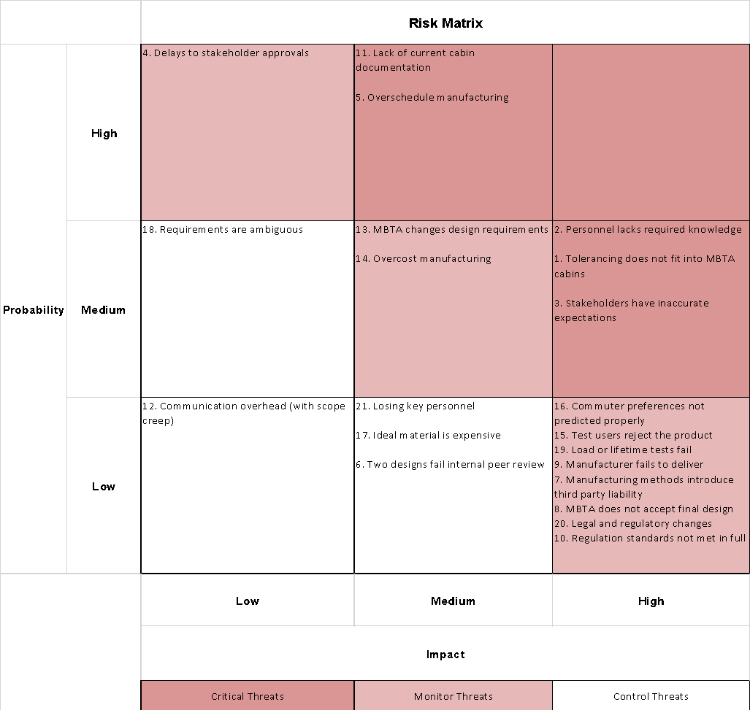

## Quantitative Risk Analysis

With the qualitative risk analysis completed, the team was able to develop a more thorough, quantitative risk analysis. Severity was rated from 1-10, where 1 means “barely affects project,” either in terms of cost, deadline, or achievement of goals. A severity rating of 10 is defined as a complete project blockage, which causes one of the following: huge costs to fix, a large delay in schedule, or a complete lack of fulfilled project goals. Likelihood and ability to detect were completed on a 1-10 scheduled, where 1 represents the least likely and the easiest to detect, and where 10 represents the most likely and most difficult to detect.

The risk priority number (RPN) was also calculated as the product of the severity, likelihood, and ability to detect, and allows the team to have an idea of the risks which are expected to most negatively affect NEUDesigner’s work. Color coding shows risks in green which are effectively not an issue, and red, for those risks which *must* be dealt with for effective project completion.

**Table 3: FMEA Risk Analysis**

|  |  |  |  |  |  |
| --- | --- | --- | --- | --- | --- |
| **Severity:** Rated 1-10, where 10 is most severe negative risk  **Likelihood:** Rated 1-10, where 10 is most likely to occur  **Ability to Detect:** Rated 1-10, where 10 is most difficult to detect  Green represents lowest risk priority number – the least risk  Red represents highest risk priority number – the most risk | | | | | |
| **Risk Category** | **Risk** | **Severity** | **Likelihood** | **Ability to Detect** | **RPN** |
| 1. Client/ stakeholder | 1.1 Requirements are ambiguous | 3 | 5 | 1 | 15 |
| 1.2 Communication overhead (with scope creep) | 4 | 2 | 5 | 40 |
| 1.3 MBTA changes design requirements | 7 | 5 | 1 | 35 |
| 1.4 Lack of current cabin documentation | 5 | 8 | 1 | 40 |
| 1.5 Delays to stakeholder approvals | 4 | 8 | 5 | 160 |
| 1.6 MBTA does not accept final design | 10 | 1 | 8 | 80 |
| 1.7 Stakeholders have inaccurate expectations | 8 | 5 | 5 | 200 |
| 2. End user | 2.1 Commuter preferences not predicted properly | 8 | 3 | 1 | 24 |
| 3. Internal | 3.1 Losing key personnel | 5 | 1 | 1 | 5 |
| 3.2 Personnel lacks required knowledge | 8 | 5 | 5 | 200 |
| 4. Design | 4.1 Ideal material is expensive | 7 | 3 | 1 | 21 |
| 4.2 Two designs fail internal peer review | 7 | 2 | 8 | 112 |
| 5. External (regulatory) | 5.1 Legal and regulatory change | 10 | 1 | 1 | 10 |
| 5.2 Regulation standards not met in full | 10 | 1 | 5 | 50 |
| 6. Mfg. | 6.1 Overcost manufacturing | 5 | 5 | 1 | 25 |
| 6.2 Manufacturer fails to deliver | 10 | 1 | 5 | 50 |
| 6.3 Manufacturing methods introduce third party liability | 10 | 1 | 8 | 80 |
| 6.4 Overschedule manufacturing | 6 | 5 | 5 | 150 |
| 7. Testing | 7.1 Test users reject the product | 8 | 3 | 1 | 24 |
| 7.2 Load or lifetime test fails | 10 | 1 | 1 | 10 |
| 7.3 Tolerancing does not fit into MBTA cabins | 10 | 5 | 5 | 250 |

## Risk Response Planning

The prior quantitative risk assessment feeds directly into the team’s plan for how to deal with these risks. In general, low RPN corresponds with “accept” (no action), while higher RPN corresponds to “mitigate” or “avoid.” *Avoid* is considered to be the most drastic action, while *mitigate* calls for a relatively less involved action. Transferring of risk happens at all levels of RPN. The general plan for dealing with these risks is detailed in the column “Plan or Rationale.”

The plan attempts to improve the severity, likelihood, or ability to detect (or some combination of the three). Rationale is given for those risks which will be accepted.

**Table 4: Risk Response Planning**

|  |  |  |  |
| --- | --- | --- | --- |
| **Risk Category** | **Risk** | **Action** | **Plan or Rationale** |
| 1. Client/ stakeholder | 1.1 Requirements are ambiguous | Mitigate | This is very likely, so mitigation would involve good communication practices with the client. |
| 1.2 Communication overhead (with scope creep) | Mitigate | The ability to detect scope creep will be mitigated through good communication practices with the client (such as requiring all decisions to be made in writing, or in a documented meeting minutes format). |
| 1.3 MBTA changes design requirements | Accept | The client does have the ability to change design requirements, so this must be accepted. |
| 1.4 Lack of current cabin documentation | Mitigate | The design team will collect all documentation from the MBTA as soon as possible, and assess if mitigation needs to occur (such as creating our own cabin documentation). |
| 1.5 Delays to stakeholder approvals | Accept | The MBTA can be a slow moving organization. Key signatures and inputs can sometimes delay the project timeline. Beyond communicating with the MBTA, this is mostly outside of our control |
| 1.6 MBTA does not accept final design | Avoid | Frequent communication and sign-offs after each project phase will decrease the likelihood of this happening. |
| 1.7 Stakeholders have inaccurate expectations | Mitigate | Good communication practices can easily mitigate this risk. |
| 2. End user | 2.1 Commuter preferences not predicted properly | Mitigate | The task “Conduct consumer preference research and analyze data” mitigates this risk. |
| 3. Internal | 3.1 Losing key personnel | Accept | As with any startup environment, some staff turnover is normal, and must simply be dealt with as it comes. |
| 3.2 Personnel lacks required knowledge | Transfer | The employees of NEUDesigners are not transportation experts. Any knowledge gaps that arise will be filled with hiring experienced consultants. |
| 4. Design | 4.1 Ideal material is expensive | Accept | This is acceptable (within reason). The long lifetime of our parts means that high material cost is possible, but would be justifiable to the client, as materials are a one-time expense. |
| 4.2 Two designs fail internal peer review | Avoid | If two designs fail our internal review, some large oversight has occurred. The likelihood will be reduced by involving several engineers in the design process and by having daily meetings of the design team. |
| 5. External (regulatory) | 5.1 Legal and regulatory change | Transfer | To transfer this risk, legal counsel would review documentation to ensure all regulations are met. |
| 5.2 Regulation standards not met in full | Mitigate | See above. Also, the team will communicate with the MBTA to have all regulatory documents made available to us. |
| 6. Mfg. | 6.1 Overcost manufacturing | Accept | Rapid prototyping generally incurs high cost – this is normal. |
| 6.2 Manufacturer fails to deliver | Mitigate | Complete failure to deliver is always high severity. The likelihood and ability to detect can be improved by thoroughly vetting potential manufacturers. |
| 6.3 Manufacturing methods introduce third party liability | Transfer | Again, legal counsel will ensure that our manufacturing methods, and the methods of our chosen manufacturer, do not infringe on any intellectual property. |
| 6.4 Overschedule manufacturing | Accept | Manufacturing could miss deadlines – this is a common risk in our industry , and must be accepted. |
| 7. Testing | 7.1 Test users reject the product | Mitigate | The commuter perception is critical to project success. Likelihood of rejection will be mitigated by having consumer surveys early-on in design process. |
| 7.2 Load or lifetime test fails | Avoid | This unlikely risk will be completely avoided during the design phase, via extensive computer simulation. |
| 7.3 Tolerancing does not fit into MBTA cabins | Mitigate | With old cabins, lack of proper documentation and worn down cabin interfaces are very likely. The severity of this could be decreased by measuring the cabins early-on, and comparing to the MBTA’s available cabin drawings. |

# Financial Plan with Budget

## High Level Details

The team proposes a budget of $75,664 for successful on-time completion of this project. To guarantee a successful management of the project, keeping track of the estimated budget is a priority. This budget is proposed to determine the anticipated costs of the initial stages of the project’s life cycle and their assigned resources. The budget will be updated during the project’s life cycle accordingly to support the project progress. Any updates to the budget that occur during the project life cycle will be reported to all the internal investors, stakeholders and executive managers as it will help to maintain transparency between the investors and the Project Managers.

**Table 5: High-Level Project Budget**

|  |  |
| --- | --- |
| Project Phases | Estimated Budget |
| Initiation   * Develop business case based on MBTA’s RFP * Establish project charter and goals * Appoint Project team | $4,900 |
| Planning   * Develop project schedule * Market research * Consumer surveys * Budgeting: estimating costs and risks | $17,420 |
| Execution   * Design plan * Design evaluation * Finalize design package * Design manufacturing * Prototyping and testing | $50,124 |
| Termination   * Compilation of all deliverables | $3,220 |
| Total Budget | **$75,664** |

The following image shows the budget distribution over the course of the project; execution requires the majority of the budget as well as the majority of the project timeline.

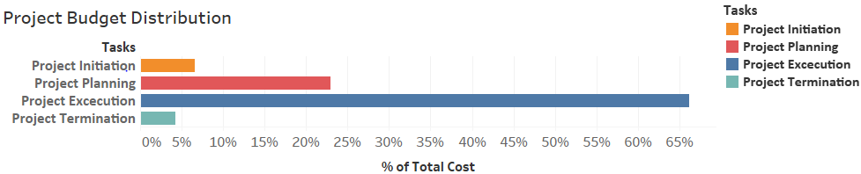

**Figure 3:** **Project Budget Distribution**

## Budget Justification

The budget was formed based on the anticipated costs and total investments. The estimated budget reflects the wages of on-staff engineers and external engineers, cost of rapid manufacturing, testing the prototypes of the new designs and the consumer surveys. Refer to Appendix D for the complete budget justification.

# Team Credentials

**Aleksandra Pirog**

Aleksandra is pursuing her Bachelor’s Degree in Mechanical Engineering. She has completed two co-ops in the product design and quality analysis fields, and mainly worked in analyzing and modifying their current products. Aleksandra is also a cadet in the U.S. Army. Aleksandra thrives in innovations, having successfully analyzed customer proposals in order to create a product or service that meets both the needs of the client and her company. She will use this experience in the managing the execution of the project.

**Sarah Witzig**

Sarah is pursuing her Bachelor’s Degree in Mechanical Engineering. She has completed three co-ops in the medical and aviation industries, and has a background in quality, test, and automation. Sarah’s main areas of expertise are technical writing and software test and development. She will use this experience to write effective communications and ensure the quality of our external suppliers.

**Gaurav Korgaonkar**

Gaurav is pursuing his Master’s Degree in Engineering Management, and has completed a Bachelor’s degree in Electronics and Telecommunication. During his undergraduate degree, he completed two internships in the software and technology industries. Gaurav’s main areas of expertise are data quality, analysis, and reporting; utilizing these skills to help his previous organizations with important business decisions. He will use his experience in assessing the project risks, carrying out contingencies if necessary.

**Daniel Gallagher**

Daniel is pursuing his BS/MS degrees in Mechanical Engineering. He has completed two internships in the medical industry and one in the automotive industry, which gave him experience in research and development, design, and test engineering. Daniel’s main area of expertise is in research and development, product design and validation. He will use his experience in managing the technical team designing the project’s seat configuration.

**Paul Kfoury**

Paul is pursuing his Bachelor’s Degree in Industrial Engineering, with minors in Mechanical Engineering and Mathematics. He has completed three co-ops for companies in the health and defense industries, and gained experience in electromechanical manufacturing, quality, and process engineering. Paul’s main areas of expertise include process creation, testing, and validation, as well as, statistical data analysis, statistical process control, and the implementation of Lean and Six Sigma. He will use his experience to optimize the planning processes and implementation.

**Peter Veneto**

Peter is pursuing a Master's Degree in Mechanical Engineering, with a focus in Mechanics. He has completed three co-ops in the medical, manufacturing, and industrial industries, where he gained knowledge of material science, manufacturing processes, quality assurance, and product design. Peter specializes in mechanical design, manufacturing, product development, and computer aided design. He will use his experience to help manage the technical design of the seating and the internal layout of the train cars.

# APPENDIX A – WORK BREAKDOWN STRUCTURE

# APPENDIX B – SCHEDULE AND GANTT CHART

|  |  |  |  |  |  |  |
| --- | --- | --- | --- | --- | --- | --- |
| **#** | **Task Name** | **Duration** | **Start** | **Finish** | **Predecessors** | **Resource Names** |
|  | **MBTA Orange Line Redesign** | **101.2 days** | **Mon 9/4/17** | **Tue 1/23/18** |  |  |
| 1 | **Initiation** | **10 days** | **Mon 9/4/17** | **Fri 9/15/17** |  |  |
| 2 | Develop business case based on MBTA's RFP | 5 days | Mon 9/4/17 | Fri 9/8/17 |  | Project Manager |
| 3 | Establish project charter and goals | 3 days | Mon 9/11/17 | Wed 9/13/17 | 2 | Project Manager |
| 4 | Appoint project team | 2 days | Thu 9/14/17 | Fri 9/15/17 | 3 | Project Manager |
| 5 | **Planning** | **22 days** | **Mon 9/18/17** | **Tue 10/17/17** | **1** |  |
| 6 | **Develop project schedule** | **3 days** | **Mon 9/18/17** | **Wed 9/20/17** | **1** |  |
| 7 | Build work breakdown structure | 1 day | Mon 9/18/17 | Mon 9/18/17 | 1 | Project Manager |
| 8 | Develop resource allocation plans | 1 day | Tue 9/19/17 | Tue 9/19/17 | 7 | Project Manager |
| 9 | Define dependencies and develop project schedule | 1 day | Wed 9/20/17 | Wed 9/20/17 | 8 | Project Manager |
| 10 | **Budgeting: estimating costs and risks** | **5 days** | **Thu 9/21/17** | **Wed 9/27/17** | **6** |  |
| 11 | Prepare financial budget | 3 days | Thu 9/21/17 | Mon 9/25/17 | 1 | Cost Engineer |
| 12 | Identify risks | 0.5 days | Tue 9/26/17 | Tue 9/26/17 | 11 | Project Manager, Quality Engineer |
| 13 | Analyze risks | 0.5 days | Tue 9/26/17 | Tue 9/26/17 | 12 | Project Manager, Quality Engineer |
| 14 | Form risk management plans | 1 day | Wed 9/27/17 | Wed 9/27/17 | 13 | Project Manager |
| 15 | **Market/literature research** | **19 days** | **Thu 9/21/17** | **Tue 10/17/17** | **6** |  |
| 16 | Analyze MBTA current status | 1 day | Thu 9/21/17 | Thu 9/21/17 |  | R&D Engineer |
| 17 | Research designs used by other transportation providers | 3 days | Fri 9/22/17 | Tue 9/26/17 | 16 | R&D Engineer |
| 18 | Conduct consumer preference research and analyze data | 15 days | Thu 9/21/17 | Wed 10/11/17 | 1 | Human Factors Engineer |
| 19 | Identify areas of design improvement | 4 days | Thu 10/12/17 | Tue 10/17/17 | 17,18 | R&D Engineer[50%],Human Factors Engineer[50%] |
| 20 | **Execution** | **63.2 days** | **Wed 10/18/17** | **Mon 1/15/18** | **5** |  |
| 21 | **Design Plan** | **26 days** | **Wed 10/18/17** | **Wed 11/22/17** | **5** |  |
| 22 | Develop design requirements | 2 days | Wed 10/18/17 | Thu 10/19/17 | 5 | Lead Mechanical Engineer |
| 23 | Material selection | 5 days | Fri 10/20/17 | Thu 10/26/17 | 22 | Materials Engineer |
| 24 | Design for seats and handholds | 10 days | Fri 10/27/17 | Thu 11/9/17 | 23 | Industrial Designer |
| 25 | CAD drawings | 6 days | Fri 11/10/17 | Fri 11/17/17 | 24 | Lead Mechanical Engineer, Materials Engineer, R&D Engineer |

|  |  |  |  |  |  |  |
| --- | --- | --- | --- | --- | --- | --- |
| **#** | **Task Name** | **Duration** | **Start** | **Finish** | **Predecessors** | **Resource Names** |
| 26 | Train cabin layout configuration | 3 days | Mon 11/20/17 | Wed 11/22/17 | 25 | Lead Industrial Engineer, Human Factors Engineer |
| 27 | **Design evaluation** | **1.2 days** | **Thu 11/23/17** | **Fri 11/24/17** | **21** |  |
| 28 | Cost-benefit/decision analysis | 0.5 days | Thu 11/23/17 | Thu 11/23/17 | 21 | Project Manager, Cost Engineer, Human Factors Engineer, Lead Industrial Engineer, Lead Mechanical Engineer, Quality Engineer, Railway Engineer |
| 29 | FMEA risk analysis | 0.5 days | Thu 11/23/17 | Thu 11/23/17 | 28 | Project Manager, Cost Engineer, Human Factors Engineer, Lead Industrial Engineer, Lead Mechanical Engineer, Quality Engineer, Railway Engineer |
| 30 | Design selection | 0.2 days | Fri 11/24/17 | Fri 11/24/17 | 29,28 | Project Manager |
| 31 | **Finalize design package** | **16 days** | **Fri 11/24/17** | **Mon 12/18/17** | **27** |  |
| 32 | Finalize material selection | 5 days | Fri 11/24/17 | Fri 12/1/17 | 21 | Materials Engineer |
| 33 | Finalize CAD designs | 5 days | Fri 12/1/17 | Fri 12/8/17 | 32 | Lead Mechanical Engineer |
| 34 | Finalize layout configuration | 5 days | Fri 12/8/17 | Fri 12/15/17 | 33 | Lead Industrial Engineer |
| 35 | Compile design package | 1 day | Fri 12/15/17 | Mon 12/18/17 | 34,32,33 | Project Manager |
| 36 | **Develop manufacturing strategy** | **4 days** | **Mon 12/18/17** | **Fri 12/22/17** | **31** |  |
| 37 | Develop build and assembly procedures | 3 days | Mon 12/18/17 | Thu 12/21/17 | 31 | Lead Industrial Engineer, Manufacturing Engineer |
| 38 | Manufacturing cost analysis | 1 day | Thu 12/21/17 | Fri 12/22/17 | 37 | Cost Engineer |
| 39 | **Prototyping and testing** | **12 days** | **Fri 12/22/17** | **Tue 1/9/18** | **36** |  |
| 40 | Develop and send out request for manufacturing | 1 day | Fri 12/22/17 | Mon 12/25/17 | 36 | Project Manager |
| 41 | Evaluate possible manufacturers and select one | 1 day | Mon 12/25/17 | Tue 12/26/17 | 40 | Project Manager |
| 42 | Contractor manufactures prototypes | 5 days | Tue 12/26/17 | Tue 1/2/18 | 41 | Manufacturer |
| 43 | Mechanical testing (load and lifetime) | 5 days | Tue 1/2/18 | Tue 1/9/18 | 42 | Lead Mechanical Engineer, Quality Engineer |
| 44 | **Develop installation and cleaning procedures** | **4 days** | **Tue 1/9/18** | **Mon 1/15/18** | **39** |  |
| 45 | Develop installation SOPs | 2 days | Tue 1/9/18 | Thu 1/11/18 | 39 | Lead Industrial Engineer |
| 46 | Develop cleaning instructions | 2 days | Thu 1/11/18 | Mon 1/15/18 | 45 | Manufacturing Engineer |
| 47 | **Termination** | **6 days** | **Mon 1/15/18** | **Tue 1/23/18** | **44** |  |
| 48 | **Project delivery to MBTA** | **6 days** | **Mon 1/15/18** | **Tue 1/23/18** | **20** |  |
| 49 | Compile all deliverables | 5 days | Mon 1/15/18 | Mon 1/22/18 | 20 | Project Manager |
| 50 | Submit all deliverables and reports to client for signoff | 1 day | Mon 1/22/18 | Tue 1/23/18 | 49 | Project Manager |

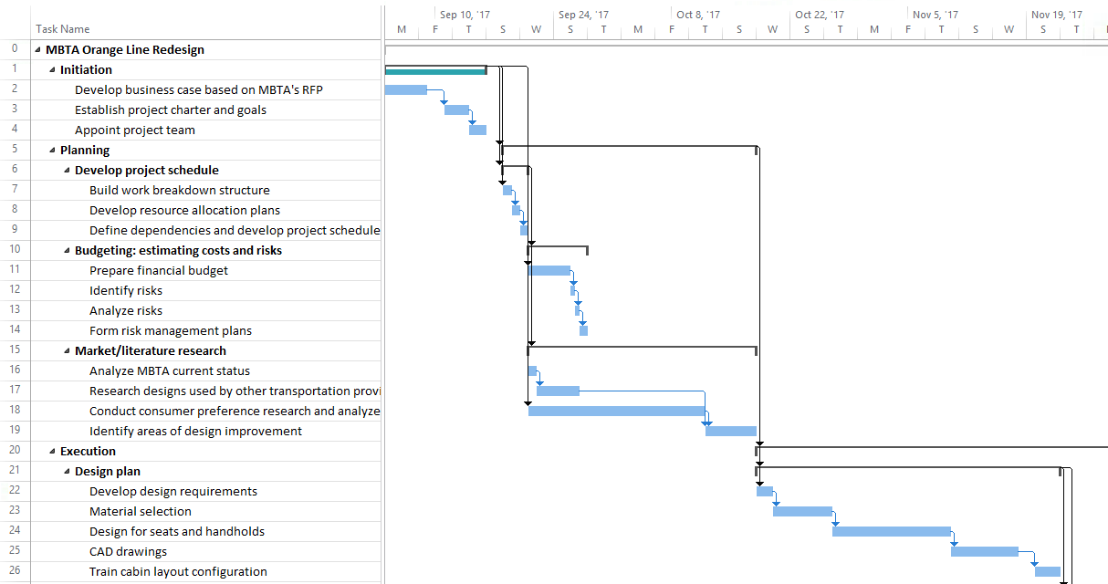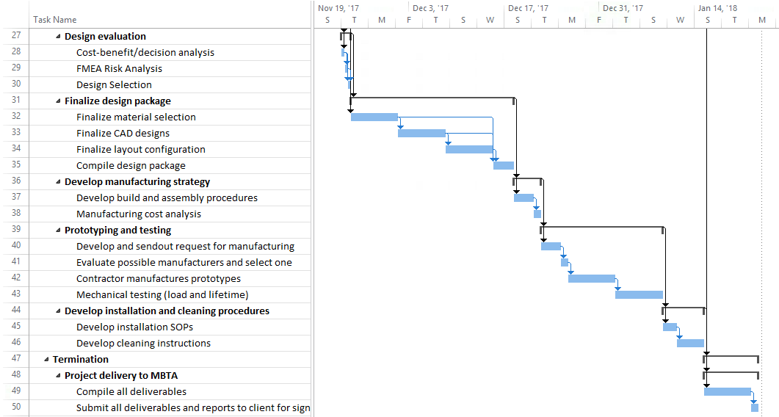

# APPENDIX C – RACI MATRIX

# 

# APPENDIX D – BUDGET

|  |  |  |  |  |  |  |  |  |
| --- | --- | --- | --- | --- | --- | --- | --- | --- |
| **Project Phase** | **Staff Wages** | | | | **Materials** | | **Misc.** | **Total Cost** |
| **Qty.** | **Working Hours** | **Hourly Pay** | **Cost** | **Qty.** | **Cost** |
| **1. Initiation** | | | | | | | | |
| 1.1 Develop business case based on MBTA’s RFP | 1 | 40 | $60 | $2,400 |  |  |  | $2,400 |
| 1.2 Appoint project team and assign project goals | 1 | 40 | $60 | $2,400 |  |  | $100 | $2,600 |
| **Total Phase cost** | | | | | | | | **$4,900** |
| **2. Planning** | | | | | | | | |
| 2.1 Develop project schedule | 1 | 24 | $60 | $1,440 |  |  |  | $1,440 |
| 2.2 Budgeting: estimating costs and risks | | | | | | | | |
| *2.2.1* Create financial budget | 1 | 24 | $55 | $1,320 | 1 | $200 |  | $1,520 |
| *2.2.2* Identify risks | 1 | 4 | $65 | $520 |  |  |  | $520 |
| *2.2.3* Analyze risks | 1 | 4 | $65 | $520 |  |  |  | $520 |
| *2.2.4* Form risk management plans | 1 | 8 | $65 | $520 |  |  |  | $520 |
| 2.3 Market/literature research | | | | | | | | |
| *2.3.1* Research designs used by other  transportation providers | 1 | 32 | $70 | $2,240 |  |  |  | $2,240 |
| *2.3.2* Conduct consumer surveys and analyze data | 2 | 40 | $50 | $4,000 | 2 | $2,000 | $500 | $6,500 |
| *2.3.3* Identify areas of design improvement | 2 | 32 | $65 | $4,160 |  |  |  | $4,160 |
| **Total Phase cost** | | | | | | | | **$17,420** |
| **3. Execution** | | | | | | | | |
| 3.1 Design plan | | | | | | | | |
| *3.1.1* Develop design requirements | 1 | 40 | $70 | $2,800 | 1 | $500 |  | $3,300 |
| *3.1.2* Selection of material | 1 | 40 | $60 | $2,400 |  |  |  | $2,400 |
| *3.1.3* Work on CAD drawings | 3 | 40 | $65 | $7,800 | 3 | $600 | $100 | $8,500 |
| *3.1.4* Train cabin layout configuration | 2 | 24 | $65 | $3,120 |  |  |  | $3,120 |
| 3.2 Design evaluation | | | | | | | | |
| *3.2.1* Cost-benefit/ decision analysis | 7 | 4 | $64 | $1,792 | 1 | $300 |  | $2,092 |
| *3.2.2* FEMA risk analysis | 7 | 4 | $64 | $1,792 |  |  |  | $1,792 |
| *3.2.3* Design selection | 1 | 4 | $65 | $260 |  |  |  | $260 |
| 3.3 Finalize design package | | | | | | | | |
| *3.3.1* Finalize materials, CAD designs and layouts | 2 | 40 | $70 | $5,600 |  |  |  | $5,600 |
| *3.3.2* Compile design package | 1 | 8 | $65 | $520 |  |  | $100 | $620 |
| 3.4 Develop manufacturing strategy | | | | | | | | |
| *3.4.1* Develop build and assembly procedures | 2 | 24 | $70 | $3,360 | 1 | $150 |  | $3,510 |
| *3.4.2* Manufacturing cost analysis | 1 | 8 | $60 | $480 |  |  |  | $480 |
| 3.5 Prototyping and testing | | | | | | | | |
| *3.5.1* Evaluation and selection of manufacturers | 1 | 8 | $65 | $520 |  |  | $200 | $720 |
| *3.5.2* Contractor manufactures prototypes |  |  |  |  | 1 | $10,000 |  | $10,000 |
| *3.5.3* Mechanical testing | 2 | 40 | $65 | $5,200 | 2 | $450 |  | $5,650 |
| 3.6 Develop installation and cleaning procedure | | | | | | | | |
| *3.6.1* Develop installation SOPs | 1 | 16 | $65 | $1,040 |  |  |  | $1,040 |
| *3.6.2* Develop cleaning instructions | 1 | 16 | $65 | $1,040 |  |  |  | $1,040 |
| **Total Phase cost** | | | | | | | | **$50,124** |
| **4. Termination** | | | | | | | | |
| 4.1 Compile all deliverables | 1 | 40 | $65 | $2,600 |  |  | $100 | $2,700 |
| 4.2 Submit all deliverables and reports to the client | 1 | 8 | $65 | $520 |  |  |  | $520 |
| **Total Phase cost** | | | | | | | | **$3,220** |
| **Total Project Cost** | | | | | | | | **$75,664** |

1. T. Dutzik. (2016, January 18). “Boston is Growing Fast. So Is Ridership on the MBTA.”  [Online]. Available: [/www.t4ma.org/boston_is_growing](http://www.t4ma.org/boston_is_growing)
2. K.S. Clauss. (2016, June 6). “The Curmudgeon’s Guide to the Orange Line.” [Online]. Available: [www.bostonmagazine.com/news/blog/2016/06/06/mbta-orange-line-guide/](http://www.bostonmagazine.com/news/blog/2016/06/06/mbta-orange-line-guide/)
3. “The MBTA Vehicle Inventory Page.” [Online]. Available: <http://www.transithistory.org/roster/>
4. A. Vacaro. (2015, October 22). “Here’s how much your commute costs the MBTA.” [Online]. Available:  <https://www.boston.com/news/business/2015/10/22/heres-how-much-your-commute-costs-the-mbta>
5. S. Witzig, *Folding seats in Frankfurt*. 2017.
6. “Subway R160 Interior With Double Stanchions.”  [Online]. Available: https://upload.wikimedia.org/wikipedia/commons/1/10/ NYC_Subway_R160_9800_Interior_with_Double_Stanchions.jpg
7. “Subway R160 Interior With Double Stanchions.” [Online]. Available: https://upload.wikimedia.org/wikipedia/commons/1/10/ NYC_Subway_R160_9800_Interior_with_Double_Stanchions.jpg
8. “Empty Subway in NYC.” (21 April. 2006). [Online]. Available: https://commons.wikimedia.org/wiki/File:Empty_ subway_ in_NYC.jpg